Project Design Phase-II
Data Flow Diagram & User Stories

Date | 13 July 2026
Team ID
Project Name | Visualizing Housing Market Trends: An Analysis of Sale Prices and Features using Tableau
Maximum Marks | 4 Marks

Data Flow Diagrams:
A Data Flow Diagram (DFD) is a traditional visual representation of the information flows within a system. A clear DFD depicts the right amount of the system requirement graphically — how data enters and leaves the system, what changes the information, and where data is stored.

DFD Level 0 — Context Diagram
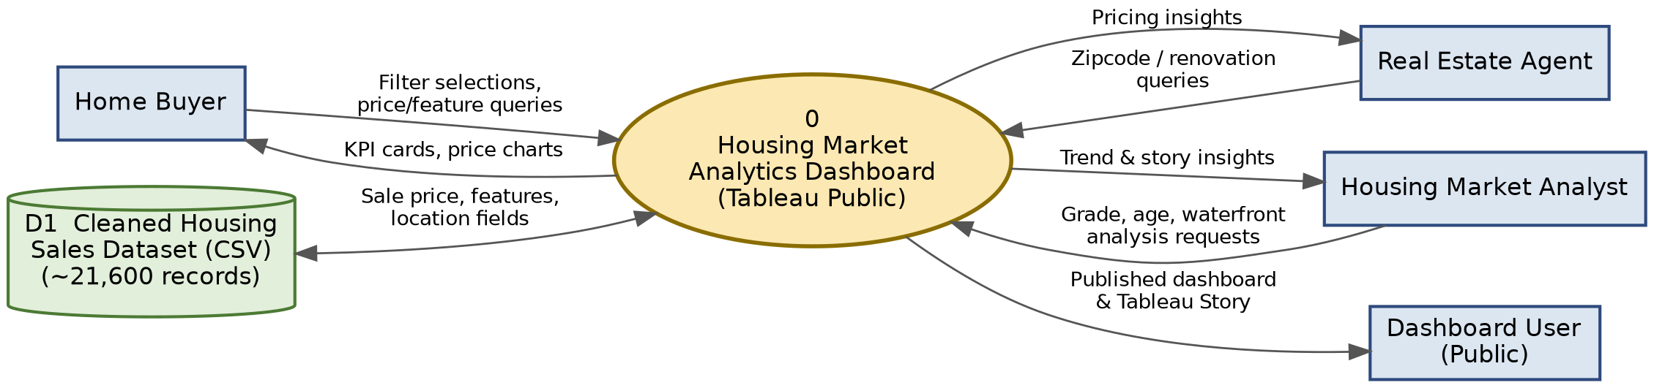

DFD Level 1 — Process Breakdown
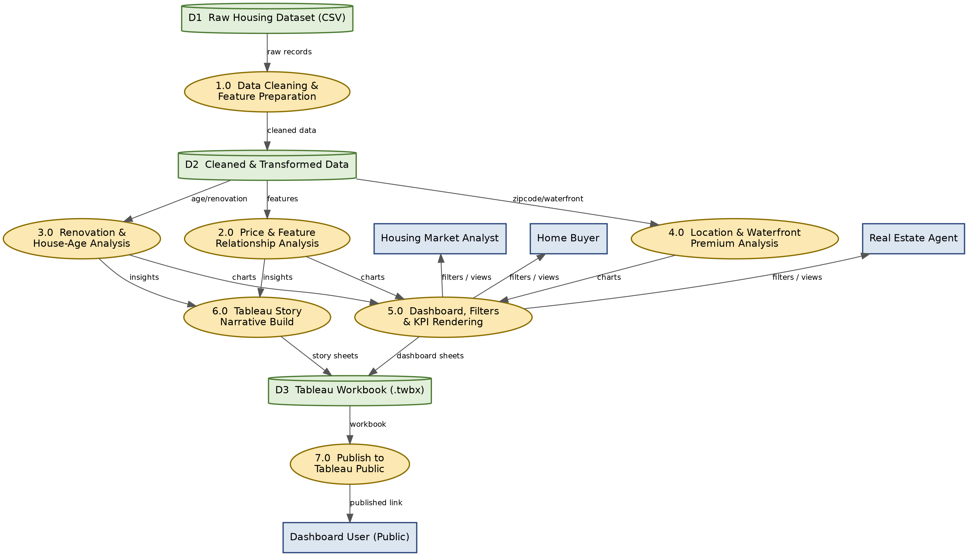
User Stories
Use the below template to list all the user stories for the product.
User Type | Functional Requirement (Epic) | Story # | User Story / Task | Acceptance Criteria | Priority | Release
Home Buyer | KPI Dashboard | USN-1 | As a Home Buyer, I want to view key KPIs such as total properties, average sale price, and total living area so that I can quickly gauge overall market conditions. | KPI cards display accurate, up-to-date totals when the dashboard loads. | High | Sprint-1
 | Interactive Filters | USN-2 | As a Home Buyer, I want to filter listings by zipcode group and price range so that I can focus on homes within my budget and preferred location. | Selecting a filter updates all visible charts and KPIs without a page reload. | High | Sprint-1
 | Price & Feature Analysis | USN-3 | As a Home Buyer, I want to see how sale price varies with bedrooms and bathrooms so that I can judge whether a listing is fairly priced. | Price-by-feature chart updates correctly when filters are applied. | Medium | Sprint-2
Real Estate Agent | Renovation Impact Analysis | USN-4 | As a Real Estate Agent, I want to analyse how renovation status and years since renovation affect sale price so that I can advise clients on renovation-driven pricing. | Renovation chart shows an accurate breakdown of sale counts / prices by renovation status. | High | Sprint-2
 | Location-wise Price Analysis | USN-5 | As a Real Estate Agent, I want to compare price trends across zipcode groups so that I can recommend competitive listing prices to sellers. | Zipcode-wise chart reflects average / total sale price matching the underlying dataset. | Medium | Sprint-2
 | House Age Analysis | USN-6 | As a Real Estate Agent, I want to view house-age distribution by bedrooms, bathrooms and floors so that I can identify which configurations are common in older vs. newer homes. | Age-distribution chart correctly facets by bedrooms, bathrooms and floors. | Medium | Sprint-3
Housing Market Analyst | Price & Feature Relationship Analysis | USN-7 | As a Housing Market Analyst, I want to explore the relationship between overall grade / condition and sale price so that I can quantify how quality drives value. | Grade vs. price chart shows a clear, correctly aggregated relationship. | High | Sprint-1
 | Waterfront & View Premium Analysis | USN-8 | As a Housing Market Analyst, I want to analyse the waterfront-view premium so that I can measure its impact on sale price. | Waterfront comparison view shows average price with and without a waterfront view. | Medium | Sprint-3
 | Tableau Story | USN-9 | As a Housing Market Analyst, I want to walk through a guided Tableau Story summarising key housing findings so that I can present insights without rebuilding charts. | Story points navigate in sequence and each point displays its correct supporting visualization. | Medium | Sprint-3
 | Renovation Impact Analysis | USN-10 | As a Housing Market Analyst, I want to track total sales by years since renovation so that I can identify how recency of renovation influences market activity. | Sales-by-renovation chart displays correct totals for each renovation-year bucket. | High | Sprint-1
 | Interactive Filters | USN-11 | As a Housing Market Analyst, I want interactive filters for bedrooms, bathrooms and zipcode group so that I can drill into specific market segments. | Applying any filter updates all dependent charts and KPI cards consistently. | High | Sprint-1
Dashboard User | Public Access & Sharing | USN-12 | As a Dashboard User, I want to access the published Tableau dashboard and story directly via Tableau Public so that I can view insights without installing any software. | The Tableau Public page loads the dashboard and story correctly in common browsers. | High | Sprint-1
 | Dashboard Visualization | USN-13 | As a Dashboard User, I want the dashboard layout to be clear and easy to navigate so that I can find the information I need without confusion. | Navigation between dashboard sections (KPI, Price, Renovation, Age, etc.) is available from a single visible layout. | Medium | Sprint-2
 | Interactive Filters | USN-14 | As a Dashboard User, I want to reset all filters with a single action so that I can quickly return to the default dashboard view. | A Reset Filters control clears all active filters and restores the default view. | Low | Sprint-2

